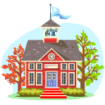
Take the Curriculum Outside: Lesson Plans For Outdoor Learning
Kirklees Environment Round Table

‘Environment through the Primary Core’ initiative:

Use of School Grounds. Habitat Papers No 1:

Buildings, Walls and Tarmac.

Collated by David Hudson, Environment Student on Work Placement.

Date: Autumn 2001

Contents Page

CONTENT | PAGE NUMBER
Introduction | 3
Early Learning | 4 - 5
Science | 6
Maths | 7
English | 8
Extra Activities | 9 – 12
Useful Sources | 12
Evaluation Form | 13

Introduction

School grounds are often just accepted as an area for the children to play in or an area to make the school look nice. This presumption often leads to their misuse. School grounds can provide many opportunities for education. This booklet looks at different activities that can be done using buildings and tarmac around the school grounds to help educate children of varying ages. Further booklets will then look at different parts of the school grounds such as playing fields and grass. The main areas looked at are the core areas of Science, Mathematics and English; extra activities are also looked at.
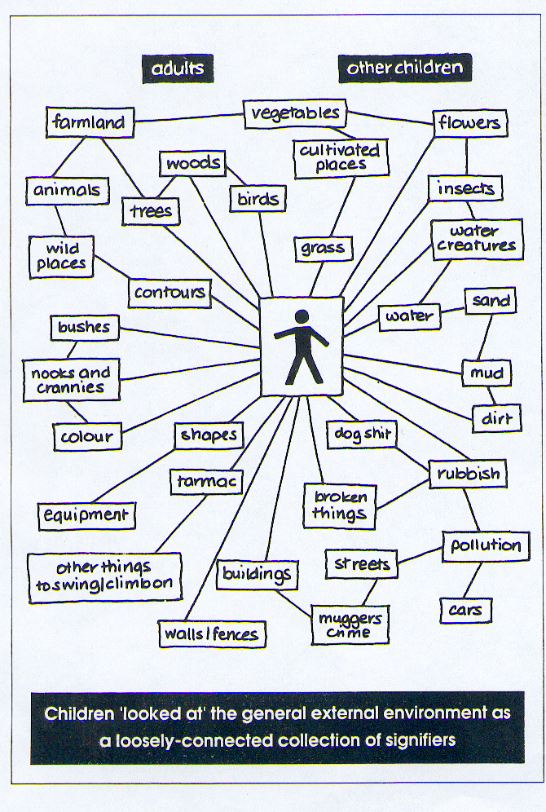
How Children Read the External Environment

By looking at how children view their environment it helps us to understand what sort of activities will be suitable. Children often read their external environment as a loosely connected collection of ‘signifiers’ (See diagram). Research has shown that children had common responses to particular signifiers because the messages and meanings were read in a cultural context, from which they formed an understanding of the place. The children’s views of places are often in negative and positive terms. Positive elements include animals and trees. Negative elements include things like litter and pollution.

Source: Special Places; Special People – The Hidden
Curriculum Of School Grounds. By The World Wide
Fund For Nature 1994

EARLY LEARNING

Promoting education in, through, about and for THE ENVIRONMENT

ENVIRONMENTAL EDUCATION FOR THE FOUNDATION STAGE
Medium Term Planning for the 6 Areas of Learning (These ideas are based on Stepping Stones’ – play & hands-on experience.)

Personal and Social Development
Opportunity to demonstrate curiosity and exploratory impulse.
Can share experiences with other members of the group.
Demonstrate ability to follow instructions – behaving well and considering safety of self and others.
Show pride in work – care in making obs. drawing/ first to find a circle….
Manage tasks and demonstrate confidence in asking for guidance and support when needed eg. In building work.
Take care of living and none living things while working in the outdoor environment.

Mathematical Development
Count eg. Windows/ doors. Compare one wall of a building with another. Identify the different shapes show an awareness of similar shapes. Make simple tallies.
Go on a numeral hunt. Look at doors/ carvings – how many do you recognise. Can you find your age?
Follow directional clues identifying the building part at the end of the trail.
Can you find which one of 2 walls is the shortest/ longest/ tallest?
Go on a 3D or 2D shape hunt. Can you keep a count of these to 5/ 10.
Can you spot any symmetrical patterns? Make rubbings of these (if possible). Can you find another one the same?
Can you work out how many bricks/ blocks/ stones similar to the one you can see it would take to build eg a sandpit?

Creative Development
Use bodies to measure walls and materials.
Make rubbings/ describe textures.
Observational drawings/ demonstrate interest.
Explores sounds striking different surfaces.
Use sense of touch and describe what they feel – use blindfolds.
Express likes/ dislikes about their surroundings.
Tell stories using features eg. cellars/ small doors/ carvings/ unusual features.

Physical Development
Move around obstacles in the built env. Adjusting speed and changing direction. Walking/ running
Construct real new features in the env. – pond, sand or gravel pit. Use one handed tools for this eg. Trowel.
Use tools and mortar (malleable material) safely as you build real life designs to develop mark-making skills
Can children manipulate materials; move big blocks safely to create desired effect?

USING THE BUILT ENVIRONMENT AROUND YOUR SCHOOL

Communication, Language and Literacy
Interact with others, negotiating plans/ taking turns in conversation about tasks.
Build up vocabulary about buildings/ materials. Is anything the same as your own house?
Use features in the built env. To develop imaginary play. Encourage children to pretend to pretend a wall is a boat/ bus/ aeroplane.
Go on a carving/ print hunt. Do you recognise any letters? Can you find letters from your name? Take photographs of your finds/ make drawings. Give meaning to marks.
Use one handed tools in building tasks.
Use water to paint on the outside walls to produce lines, circles and other marks using gross movements in this wide environment.

Knowledge and Understanding of the World
Describe simple features of buildings /explore and investigate building materials/ talk about what is seen – patterns – erosion – colours – sizes – old / new…
Demonstrate curiosity – hunt for mini beasts/ plants/ holes corners/ alcoves
Change things through design and build eg. Gravel pit/ seating/ mazes..
Use real tools and techniques safely discovering their purpose. Use digital camera.
Begin to recognise which buildings are old/ new (Built in the past /recently)
Show an interest in, comment on, notice how buildings differ eg have chimneys /do not have chimneys.

Promoting education in, through, about, and for THE ENVIRONMENT

ENVIRONMENTAL EDUCATION FOR THE FOUNDATION STAGE

USING THE BUILT ENVIRONMENT

Medium Term Planning for the 6 areas of Learning

(Play and hands on experience based on Early Learning Goals and Stepping Stones)

Objectives | Early Learning Goals/Stepping Stone | Experience | Resources
PSED  - For children to experience working in the built environment.  - Inform others about the built environment  - Can follow instructions and behave well in this WIDE environment | - Demonstrate curiosity and a strong exploratory impulse  - Seek out others to share experiences  - Have an awareness of the boundaries set and behavioural expectations within setting | - Go on a mini beast (plant) hunt.  - Show finds to group/ make drawings/ videos/ photographs/ tallies  - Work outdoors with buildings considering safety of self and others | - Magnifying boxes, trays, maps/ plans clip boards, mark makers  - Camera, video recorder, paper, clip boards, mark markers  - Wellies, macks, ropes or other markers eg. Chalk, cones.
CLL

CD

MD
PD

KUOW

SCIENCE

Materials
Survey materials around the school – buildings, playground etc. Recognition of common everyday materials and how/where they are used. Simple properties – descriptive language. Artificial or found naturally.
KS1.Sc3. Materials + Properties, 3d.
Senses
Touch trails e.g. find something smooth, rough, furry, slimy, soft, and hard
- Smells, noises or sounds.
Temperatures
Using thermometers positioned in different places on the building.
Microclimates – measurement of different weather patterns around the school building i.e., wind speed, rainfall, light level, temperature.

Forces
Experiments with push/ pull on playground.

Pollution
Survey air pollution in school ground by searching for lichens to use as indicators also setting dust traps in different sites around the building to collect airborne particles.

Evaporation
Record evaporation of puddles on the school playground.

Sound

How far can we hear?
Devise constant loudness source
Eg. Drop marble down cardboard tube onto tin or drum. What happens when we move away?
How far can we get before we can’t hear the noise?
KS1. Sc4 Physical Processes, 3d

USING THE BUILT ENVIRONMENT AROUND YOUR SCHOOL
Habitats
Plant containers in different sites around the school building according to the environmental condition i.e., light levels, temperature, and rainfall. Children choose suitable plants for different conditions.

Forces and Motion
Working outside in the playground allows use of larger objects/ measurements. Experiments with toys/ play equipment to illustrate forces + motion.
Sc4 Physical Processes
KS1- 2a,b, c
KS2- 2c

The Earth + Beyond
Pre-draw the southern skyline as seen from a point in school grounds or alternatively use laminated photographs of the same. Children plot position of sun at different times of day/ different seasons.
Shadow stick – chalk position/ length of shadow.
KS2.Sc4. Physical Processes 4b.

“Grot Line” Plants + Animals
The plants + animals of wall/ ground interface, cracks and crevices, crumbling surfaces and untrodden corners.
The plants in these areas have to live in difficult conditions and consequently often show interesting adaptations to environmental conditions. There are also a relatively small number of species with which to cope.
These plants and animals associated with them can be used to enhance Sc2 – Life Processes. KS1 1a,b. 2a,b,e,f,g. 3a,b,c. 4b. 5a,b,c. KS2. 1a,b,c. 3a,b,c,d. 4a,b,c. 5a,b,c,d,e.

Mathematics

Counting
Practical counting in a different environment. Use buildings etc. to count something “bigger” – bricks, windows, doors chimney pots etc.
KS1 Ma2. Number
1a,b,c,d,e,f,g,h,i. 2a. 4 a,b.

Data Recording
Traffic surveys – counting numbers of cars, lorries, pedestrians etc. at different times throughout the day.
- calculate the speed
Graphs
Plot bar graphs showing the number of different creatures in a given area or possibly number of different trees.

School Plan
Let the children draw a school plan to a suitable scale.

Distances
Use different measuring methods such as rulers and trundle wheels to measure distances. This information can be used to calculate different things like area, and perimeters of shapes.

Shape, Space + Measures
Look for shapes in buildings, playground, gates etc.
Measurements – large measurements. Estimation of sizes/ lengths. Measure perimeters and areas.
Follow/ give simple route instructions using appropriate language.
KS1. 1a,b,c,d,e,f. 2a,b,d. 3a,b,c. 4a,b.
KS2. 4a,b.

USING THE BUILT ENVIRONMENT AROUND YOUR SCHOOL

Angles
Using a clinometer to measure heights of buildings, trees etc.
Area of Shapes
Draw a random shape on a brick wall and using the bricks let the children try and estimate the area of the shape.

Maths Trail
Children follow a trail around the grounds carrying out a number of mathematical tests, e.g. measuring, timing and pacing etc.

Position and Movement
Following short trails by moving in different directions, i.e. forward, backwards, under, over. etc

Compass
Points of a compass, finding a bearing, pacing walking on a bearing.

English

Reading
Read signs and symbols in the school grounds Children follow a written trail around the school grounds/ playground following a series of written instructions. Children collect/ record evidence along the way as proof of their journey. Children could then design their own trails for others.
Listening
Send the children out round school to listen to the different sounds. The children should make a list of all the different sounds and put a few words at the side to describe it.

USING THE BUILT ENVIRONMENT AROUND THE SCHOOL
Writing
Describe the school building for a visitor, e.g. A Martian. Describe a story that takes place at various locations in the school grounds, possibly using a storyboard.

Poems
Write descriptive poems about the school buildings.

Questionnaire

Help children design a questionnaire to determine how the grounds make them feel. For example, use clippings from magazines depicting feelings which places may engender such as freedom, happiness or adventure. If this is too detailed, just ask “Would you spend time in the grounds if you didn’t have to?”
Descriptive Words
Choose a particular area of the school grounds e.g. the roof, a wall, a window or the playground. Then make a list of as many words as possible that describe that area.
EXTRA ACTIVITIES

Using Car Tyres

By using car tyres you are not only creating a foundation to work with, you will also be helping to recycle a product that has for a long time been difficult to dispose of.

Many companies though are now looking to the humble tyre for recycling and lessons could look at new concepts such as incorporating old tyres and glass to make roads.

Contact your local garage or tyre dealers to see if they will allow you to take a percentage of their worn tyres

Plan your garden carefully, work through each area at a time (no garden will happen overnight.).

- Wash the tyres you intend to use.
- Paint with masonry or acrylic paint to make them look nice
- You can fill the inside of the tyre with straw.
- Fasten your tyres together to the height you require using a strong wire.
- Put your tyres into the planting position and fill with correct soil type dependent on what you are planning.

Your tyre garden can be used as follows;

- Vegetables.
- Butterfly habitat (always-incorporate plants for laying eggs).
- Cottage garden
- Sensory garden
- By placing a cane wigwam inside your tyres you can grow sweet peas, runner beans etc.
- By using butyl liners inside your tyres you could create a bog garden.
- Wildflowers
- Small trees

Once you have started planting in your tyres you will come up with many more planting
opportunities.

Rotary Washing Lines

- Make a hole in the ground to ensure that the rotary washing line will be secure
- Use two old tyres to hold soil.
- Plant a climber or several climbers of your choice, a good idea is to plant at least one evergreen.
- Train your plant up the washing line. It will help if you secure some wire around the upright frame before planting.

Several of these washing lines can make a reasonable area providing shade.

Raised Pond

Although this could never be a true wildlife pond, it is certainly better than nothing at all. The area could be made safe by having a metal grill fitted just below the surface of the water.

A collection of native plants will attract many creatures to you pond. If you also place some of the tyre bog gardens close by and put in some plants like hosta and deadnettle this will be an ideal habitat for tiny newts and frogs.

Window Boxes

Window boxes provide an instant garden and the colour and scents near an open window can bring the garden into the classroom.

Boxes could be brought in at night or even bolted down using brackets.

A variety of plants, vegetables and fruit can be grown in window boxes. Should you decide this method of planting is for your school, bookshops and garden centres stocks books that give window box recipes.

Vertical Garden

By utilising school walls you can provide a habitat that will be used by a wide variety of creatures. Plants such as ivy, honey suckle and many others can be trained up wooden or wire supports, some will cling to the wall directly.
PLEASE NOTE: contact building services for advice before contemplating this project.

Bird and bat boxes can be fitted behind these plants though most birds will be happy to build their own in such an environment.

Log Pile and Loggery

It is easy to create a log pile and or a loggery in school grounds. You may have access to some old logs, parents are a good contact, failing that contact local garden landscape contractors or tree surgeons. Kirklees council parks and schools grounds staff may be able to help.

Log Pile – A simple pile of logs where the air can constantly circulate throughout the pile.
Loggery – A pile of logs and soil, when constructing this the logs and soil must contact throughout. This pile will eventually rot down, it is handy to build another as you notice change in the first loggery.

Children can monitor any changes as the loggery begins to rot. Compare the log pile to the loggery.

In time woodlice, millipedes, centipedes, slugs and snails will make their homes in these habitats.

Attracting Birds

If you have a few trees or large bushes within your school grounds, the chance of attracting birds is reasonably high.

Feeders come in all shapes and sizes and a good way to start the project off would be to have a sponsored bird feeder event (non-uniform day, instead of money get families to donate a feeder or bird food.

Once you have put your feeders in place the birds will take time to gain confidence to use them, be patient.

Ideas For Lunchtimes

Here are a number of activities devised to entertain children at lunchtimes. These ideas have been drawn from numerous areas of the curriculum especially health, science, environment and geography. As extra curricular activities all these activities are meant to be fun and require little supervision.

Playground Markings – Permanent markings can be used to supplement curriculum work, and can include grids, shapes, targets, lines on a wall for tennis, colour maps etc. Temporary lines can be drawn with playground chalk.

Quiet Areas – Not all children want to run about, some may be off colour. Quiet areas provide space for rest, conversation, reading etc.

Chess Areas – Or other board games. Benches or seats and boards made out of slabs painted can simulate a games club at lunchtimes. What about a giant chessboard from coloured paving slabs.

Trails – On prepared sheets a number of trails can be developed using the school site.

Measuring – Various trundle wheel exercises. Metre rules can be set. What about surveying the playground. Scale drawings are good, i.e. the earth, the room, the sun in scale and distance. How far can a frog jump, a cat, a leopard, the world record long jump, all marked.

Design Competitions – Plan of the environment what would you want to see. A good introduction to this sort of work – but expect 1 good idea per 100 entries

Playground Packs – Games, activities, stunts to occupy children unsupervised. Either purchased or make up your own.

Permanent Orienteering – With an adequate map of the school grounds, applicable to various age groups, a number of orientation and orienteering activities can be pre planned.

Treasure Hunts – Depending on the age, pictorial, visual or verbal collections for children to find i.e. something green, brown, soft, wooden etc.

Adventure Equipment – The siting of playground equipment can be a great bonus to a school site, but needs a great deal of pre thought (and money)

PE Equipment on loan – Old or new PE equipment can be put on loan at lunchtimes for pupils to use. The organisation of distribution and return needs to be worked out, but can be pupil managed. It does put great demand and hence stress on the equipment, it will wear out and you will loose some.

Stunts – various stunts in-groups. How many people can stand on a hydrant, a tree stump; can you get from line A to line B using only 10 steps per group etc.

Skates – Allow the kids to use roller skates.
- Ball Wall – Place markings on a wall such as goal posts or targets to aim at.
- Climbing Wall – Possibly on the reverse of the ball wall make a traverse wall, a low level wall where you climb along not up, leave out some bricks, leave others sticking out, bolt on rocks etc.
- Tactile Trail – Make up a trail for pairs – one blindfolded one sited, with various tactile sensations, i.e. brick, graved, tree bark, water, metal etc. Extend the idea for a treasure island (blindfold person. 10 steps north 15 steps east etc.
- Scented Area – In an environmental area can provide various scented plants.
- Hearing Area – Make various musical and percussion instruments fixed around the site, wind driven percussion etc.
- Allotments – In a spare area, pupil managed allotments.
- Diary walks – Like a rail, but in the form of a diary made up like a story by the teachers or the pupils i.e. “When I left Mrs Jones room I turned left and walked 10 paces and noticed that there was a red door, but I couldn’t work out the number of the lock… I carried on along by the kitchen and counted the windows … etc”.
- Colour Match – Using colour match cards from paint shops, DIY etc ask the children to find an exact match for greens, browns, greys etc.
- Photo Trail – Take a series of photographs of small scale aspects of the school exterior from unusual angles, and put the collection in a small photograph album. Give a child or a group the album and ask them to locate firstly what the photographs is of and secondly where it is taken from. This can be extended to marking the location where it was taken on a map.
- Skipping – Provide short and long ropes and a series of exercises, challenges and it will take off!

Useful Sources

www.yvbsg.org.uk – This is web site for the Yorkshire Vernacular Buildings Study Group. It includes information about vernacular architecture, which is common amongst buildings in this region. The site includes events and activities and various links.

www.berwynslate.com - This web site looks at a slate quarrying business in Wales. Some of the schools in this area have slate roofs so this site provides a graphic look into the history of quarrying slate.

www.rospa.co.uk/playsafety - This web site looks into playground safety and materials used in the playground. The site contains advice on accident prevention and the legal position.

http://familyeducation.com/article/0,1120,1-4200,00.html - This web page explains how to build your own Stonehenge. This is useful activity, which could be done easily in school grounds. It also contains links to other activities.

www.ltscotland.com/guidelines - This web site looks at many different subject areas that can be adapted to produce activities suitable for school grounds. Subjects covered include magnetism, weather and light and sound.

www.ltl.org.uk This web site offers various activities suitable for use in school grounds. The site includes a student zone and information on current projects

